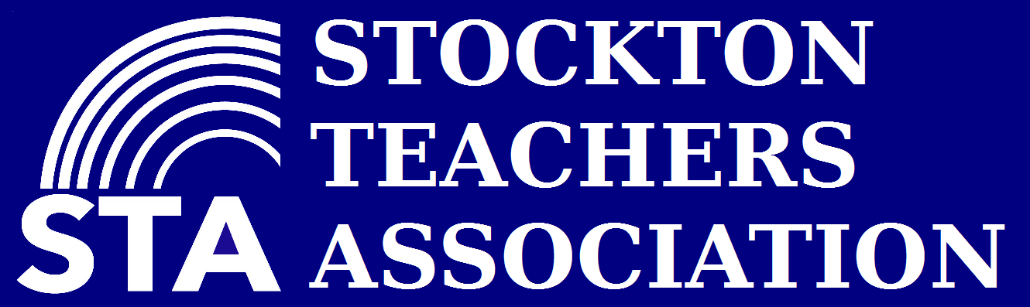 Representative Council Business Meeting
May 14, 2025
Location: STA Office
Agenda
- Call Meeting to Order
  - Land Acknowledgement: We recognize the work we do and the students and families we serve, all reside on Miwok and Yokuts Land. The Miwok, Yokuts, and other indigenous tribes were the first people here. When we teach, learn, and connect with the community, we must acknowledge the people that walked before us and their continued connection and work in the place we now live.
  - Meeting Norms (I)
- Approve
  - Minutes
    - April 9th, 2025 (A)
  - Agenda (A)
- Goals for 24-25
  - 1 on 1 Conversations
  - Worksite Leaders
  - Members Participation
  - Vision for Public Education
- Mini Training
  - Know Before You Go (I)
- Committee Reports:(Unless otherwise specified, reports should be limited to 3 minutes. Questions/comments MUST be held until the report is concluded)
  - Schedule meetings/agendas through the office
    - Budget Committee
      - Committee Recommendations (I)
      - Dues Campaign (I)
    - By-Laws/Standing Rules
      - Standing Rules second read (A)
    - Community Schools
      - Webinar 5/21/25
    - Event Planning (No report)
    - Membership Engagement (No report)
    - Real Estate
      - Update
    - Social Justice (No report)
    - Organizing
      - Members
      - Retreat 9/25
      - We Can’t Wait Petition/Cluster Check-ins
      - May 17
      - Prop 55
    - Elections
      - Special Election Spring 2025 Results
    - SPED & Disability (No report)
    - PAC (No report)
    - Bargaining (15 minutes)
    - President Report (time unlimited)
    - CTA Uniserv Staff (time unlimited)
    - Vice President Report (3 minutes)
    - Treasurer Report (3 minutes)
      - April 2025
    - Secretary (3 minutes)
- New Business/ Action items
  - STA Summer MOU (A)
  - Communications
    - Replace Constant Contact with Action Network (I)
    - Replace One Call Now with Hustle (I)
  - Email Deleting/Standing Rules (I)
  - School Safety CTA Brouchure (I)
  - Staff & PLC Calendar 2025-2026 (I)
  - DSCC Art Contest Winners (I)
  - We Can't Wait Artbuild Call for Designs (I)
  - Fremont Unified District Teachers Association Support (A)
  - CTA Budget 2025-2026 (I)
- Unfinished Business
  - Membership 2000 (I)
    - ~We are at 1915
  - New team member for Bargaining (I)
  - Dues Campaign (I)
- Upcoming Events-
  - Meetings/Trainings
    - CTA Upcoming Conferences 2025
    - CTA Awards & Scholarships
  - Events
    - Golden Key 2025 May 16th (I)
- CONCERNS & QUESTIONS

- ACTION ITEMS
  - Schedule and start Site Visits.
    - Stagg 5.15.25 (Chris)
    - Fremont 5.27.25 (Chris)
  - 10-Minute Meetings PowerPoints/Flyers
- ADJOURNMENT

